**TASK -1**

**Exploring Apple Vision Pro: A Next-Generation AR Experience**

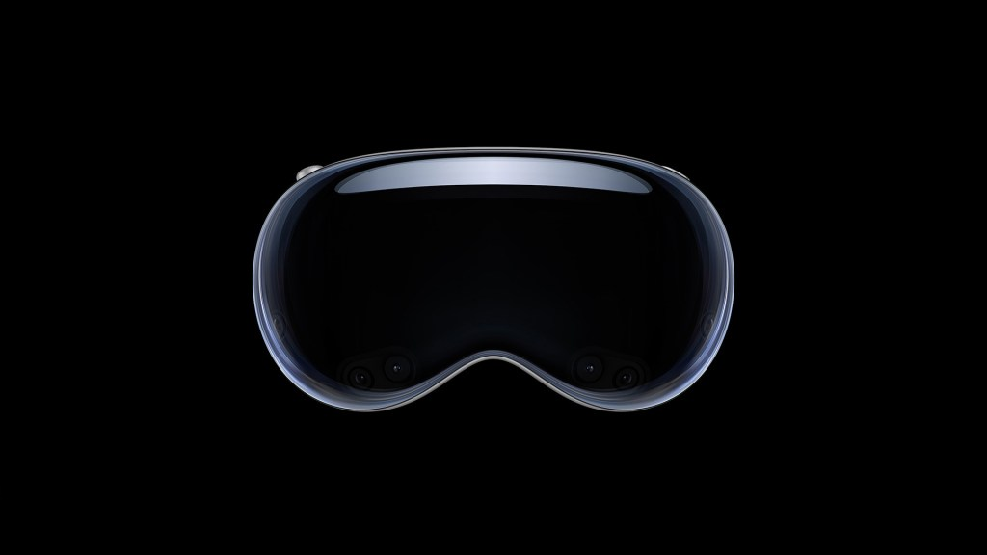

**1. Introduction**

Apple Vision Pro is a groundbreaking augmented reality (AR) headset designed to redefine digital interactions. It integrates AR with real-world environments, allowing users to engage with digital content in an immersive way. Despite its futuristic capabilities, the Vision Pro comes with limitations that impact its accessibility and practicality.

**2. Product Features & Issues**

**Key Features**

1. **Spatial Computing:** Vision Pro enables an immersive AR experience, blending digital content with the physical world.
2. **Eye & Hand Tracking:** Advanced sensors and AI-driven tracking allow intuitive navigation without a physical controller.
3. **Micro-OLED Display:** Offers ultra-high resolution with vibrant colors and sharp visuals, enhancing user experience.
4. **VisionOS:** A new operating system built specifically for spatial computing, optimizing interface responsiveness.
5. **Seamless Apple Ecosystem Integration:** Syncs smoothly with Apple devices like Mac, iPhone, and iPad.
6. **3D Camera & Spatial Audio:** Captures three-dimensional photos/videos and delivers surround sound for a more immersive feel.
7. **Augmented Productivity:** Enables users to work in a virtual environment, replacing multiple monitors with digital screens.
8. **Entertainment & Gaming:** Supports immersive movie-watching and AR gaming experiences.

**Issues & Limitations**

1. **High Price Point:** At $3,499, Vision Pro is beyond the reach of most consumers.
2. **Limited Battery Life:** Offers only about 2 hours on an external battery pack, restricting long usage sessions.
3. **Bulky Design:** The headset is relatively heavy, making extended wear uncomfortable.
4. **App Compatibility Challenges:** Not all apps are optimized for VisionOS, limiting its potential.
5. **Privacy Concerns:** Advanced eye-tracking and cameras raise questions about data security.
6. **Dependency on Apple Ecosystem:** Full functionality requires integration with Apple devices, making it less useful for non-Apple users.

**3. Inference & Future Possibilities**

The Apple Vision Pro is an innovative leap toward the future of AR and spatial computing. However, its high cost and hardware limitations make it more suited for **developers, businesses, and tech enthusiasts** rather than the average consumer.

**Possible Improvements:**

* **Lighter & More Comfortable Design:** A sleeker model would improve usability for longer sessions.
* **Extended Battery Life:** A built-in, longer-lasting battery would enhance mobility.
* **Affordable Consumer Version:** A lower-cost model could make AR accessible to a wider audience.
* **Enhanced App Support:** More third-party apps would maximize its real-world applications.

**4. Conclusion**

The **Apple Vision Pro** is a **visionary product** that showcases the potential of AR but remains an **early-stage innovation**. It is a **powerful but niche device** that may set the foundation for future AR advancements. As technology improves and prices drop, Apple Vision Pro could become a standard tool for work, entertainment, and communication in a **more connected digital world.**